|  |  |  |
| --- | --- | --- |
| **CENTRAL TOOL ROOM & TRAINING CENTER**  B-36, CHANDAKA INDUSTRIAL AREA, NEAR INFOCITY, BBSR , (O.D) 751024  Department Of PGDTD & CC | | |
| images (1) | | |
| **CERTIFICATE**  Certified that Major Project Work entitled “**GLOBAL AI IMPACT DASHBOARD**” is a Bonafide work carried out by Data Analytics 1st Batch in particular fulfillment of the requirements for the award of MASTER CERTIFICATE COURSE IN DATA ANALYTICS from CENTRAL TOOL ROOM & TRAINING CENTER, Bhubaneswar, during the year 2025. It is certified that all the correction/suggestion indicated for internal assessment have been incorporated in the report. The major project report has been approved as is satisfied the academic requirements in the respect of project work prescribed for Data Analytics, CTTC, Bhubaneswar (O.D). | | |
|  |  |  |
| …………………………………..  Workshop  In-Charge | ……………………………………  Course  Coordinator  Ritu Maity | …………………………………..  Examiner |

# ACKNOWLEDGEMENT

It is our proud privilege and duty to acknowledge the kind of help and guidance received from several people in preparation for this report. It would not have been possible to prepare this report in this form without their valuable help, cooperation, and guidance.

First and foremost, we wish to record our sincere gratitude to Management of this Training Center and to our beloved Principal, Mr. L. Rajasekhar, and Sr. Manager, Mr. Rajan K.M, CTTC, Bhubaneswar. For his constant support and encouragement in preparation of this report and for making the available library and laboratory facilities available needed to prepare this report. Our sincere thanks to Sr. Engineer Mrs. Ritu Maity, CTTC, BBSR. For his valuable suggestions and guidance throughout the period of this report. We express our sincere gratitude to our supervisor Ms Gitanjali Digal, Department of Data analytics , CTTC, Bhubaneswar for guiding us in investigations for this major project and in carrying out experimental work. Our numerous discussions with him were extremely helpful. We hold him in esteem for guidance, encouragement, and inspiration received from his.

The project on " **GLOBAL AI IMPACT DASHBOARD**" was very helpful for us in giving the necessary background information and inspiration in choosing this Project. Our sincere thanks to Ms Gitanjali Digal, for having supported the work related to this project. Their contributions and technical support in preparing this report are greatly acknowledged. Last but not the least, we wish to thank our parents for ﬁnancing our studies in this college as well as for constantly encouraging us to learn to engineer. Their personal sacriﬁce in providing this opportunity to learn engineering is gratefully acknowledged.

Place: Bhubaneswar

# DECLARATION

We the batch of Data analytics 1ST studying in the final semester of of MASTER CERTIFICATE COURSE IN Data analytics from CENTRAL TOOL ROOM & TRAINING CENTER at CTTC (Central Tool Room & Training Center), Bhubaneswar, hereby declare that this major project work entitled “**GLOBAL AI IMPACT DASHBOARD**” which is being submitted by us in the partial fulfillment for the award of the degree of Data analytics, from CTTC, Bhubaneswar is an authentic record carried out during the Training year 2025, under the supervision of Ms Gitanjali Debangi, Department of Data analytics, CTTC, Bhubaneswar.

MCCAI

Start- 15.May.2025

End- 15.Jun.2025

# ABSTRACT

Artificial Intelligence (AI) has become a transformative force globally, influencing every sector from healthcare and education to finance and manufacturing. This project explores the multi-dimensional impact of AI on a global scale, analyzing key metrics such as adoption rates, job displacement, revenue growth, consumer trust, and regulatory developments. With the help of interactive dashboards and data visualization tools, the study presents country-wise comparisons and industry-specific insights into how AI is shaping modern economies and societies.

The project investigates both the positive and challenging aspects of AI. While businesses benefit from enhanced efficiency, decision-making, and innovation, there is also a rising concern over job loss and ethical use of AI technologies. The role of human-AI collaboration emerges as a significant trend in enabling balanced automation. Regulatory frameworks, varying by region, play a critical role in guiding responsible AI deployment.

By integrating real-world data and policy analysis, the project highlights how nations are adapting to AI’s rapid evolution. It concludes that strategic governance, public trust, and inclusive development are key to maximizing AI’s potential while minimizing its risks. This report serves as a foundational resource for understanding the global AI landscape and preparing for its future trajectory.

# INDEX

ACKNOWLEDGEMENT 2

DECLARATION 3

ABSTRACT 4

INDEX 5

INTRODUCTION 6

OBJECTIVES 7

METHODOLOGY 9

KEY INDICATORS ANALYZED 12

DASHBOARD HIGHLIGHTS 14

YEAR-WISE CASE STUDY: GLOBAL AI IMPACT (2020–2025) 17

CONCLUSION 19

FUTURE SCOPE 20

REFERENCES 22

# **INTRODUCTION**

Artificial Intelligence (AI) is no longer a futuristic concept—it is a present-day reality reshaping industries, economies, and everyday life across the globe. From virtual assistants in smartphones to large-scale automation in factories, AI technologies are now embedded in how the world functions. The rapid development and deployment of AI have made it one of the most impactful technological revolutions of the 21st century.

In this project, we aim to explore the **Global impact of AI** through data-driven insights and analysis. The influence of AI extends across multiple dimensions:

* **Economic Impact**: AI contributes significantly to GDP growth through increased productivity and innovation. Countries adopting AI early are witnessing measurable revenue boosts across sectors.
* **Workforce Disruption**: Automation has led to job displacement in some industries while also creating demand for AI-related skills.
* **Industry Transformation**: Healthcare, education, transportation, finance, and manufacturing are undergoing significant AI-driven changes.
* **Ethical and Regulatory Challenges**: Governments worldwide are responding with varying degrees of regulation to ensure safe, fair, and transparent use of AI.
* **Consumer Trust**: Public perception and acceptance of AI play a vital role in its successful integration.

The global AI landscape is dynamic and uneven. While developed countries lead in research, deployment, and market share, emerging economies are catching up through strategic initiatives and investments. A major challenge lies in ensuring that AI benefits are distributed equitably and ethically, without widening existing socio-economic gaps.

Through visual dashboards and analytical tools, this project provides a comparative view of how different nations are adopting and regulating AI. It emphasizes the importance of responsible innovation, international cooperation, and human-AI collaboration in shaping the future. Ultimately, this report aims to present a holistic view of AI's global footprint and its implications for the future of work, governance, and society.

# **OBJECTIVES**

The primary goal of this project, titled **“Global AI Impact,”** is to explore and analyse the widespread effects of Artificial Intelligence across countries, industries, and socio-economic dimensions. In an era where AI is transforming everything from business models to public policy, it is essential to measure, visualize, and interpret its influence through a structured, data-driven approach.

To accomplish this, we utilized a combination of **Tableau**, **Power BI**, **Excel**, and **Python (Machine Learning)**. Each tool played a crucial role in supporting various stages of the analysis—from data cleaning and structuring to modelling and dashboard visualization.

#### Core Objectives:

1. **To analyze global AI adoption trends**-We aimed to study how different countries are adopting AI technologies over time. Using **Excel** for data preprocessing and **Power BI/Tableau** for visual representation, we showcased year-wise adoption rates across continents and industries.
2. **To evaluate the economic impact of AI**-This includes understanding how AI affects business revenues, GDP contributions, and industrial productivity. Charts and graphs were generated using **Power BI** to highlight country-wise and sector-wise revenue increases due to AI implementation.
3. **To examine job displacement and human-AI collaboration**-One of the most debated aspects of AI is its effect on employment. Through **Python (ML models)**, we explored correlations between AI adoption and job loss percentages, as well as growth in human-AI collaborative roles.
4. **To study AI-driven content creation and innovation**-Using **Excel analytics**, we evaluated the rise of AI-generated content across regions, especially in media and marketing. This was visualized in **Tableau** using comparative bar graphs and bubble charts.
5. **To compare consumer trust and sentiment toward AI**-Consumer trust is vital for the success of AI applications. We integrated survey data and processed it through **Python** to understand public opinion and sentiment trends, later visualizing the results in dashboards.
6. **To map global AI regulatory frameworks**-Countries are at different stages of developing AI policies. Our goal was to create an interactive **Power BI** dashboard categorizing nations by their level of AI governance—Full, Partial, or None.
7. **To identify the top AI tools and platforms used across regions**-By compiling global datasets on AI tool usage, we created a **word cloud and ranking visualizations in Tableau** to showcase the most adopted platforms such as ChatGPT, Midjourney, IBM Watson, and Google AI across different countries and industries.
8. **To benchmark countries by AI maturity levels**-Using a scoring model developed in **Python**, we evaluated countries based on key parameters like AI policy readiness, investment, education, and implementation. These benchmarks were presented as **indexed bar charts and maps in Power BI** for intuitive understanding.
9. **To uncover gaps and opportunities for AI in emerging economies**-We focused on low- and middle-income countries to identify under-utilized sectors with high potential for AI-driven growth. **Excel** was used for data wrangling and **Tableau** for geographic representation and opportunity mapping.

#### **Supplementary Goals:**

* **To design user-friendly dashboards** in **Tableau and Power BI** that allow easy comparison between countries, industries, and years.
* **To use machine learning models in Python** to predict future trends in AI adoption and job transformation.
* **To ensure accuracy through structured data preparation** using **Excel**, including missing value treatment, normalization, and categorization.
* **To promote interpretability** by enabling drill-down filters, slicers, and interactivity in the dashboards.

#### **Broader Purpose:**

Beyond analytics, this project serves as a **decision-support tool** for policymakers, researchers, and industry leaders. The ultimate objective is to promote **responsible and equitable AI deployment** by identifying gaps, trends, and opportunities in the global AI ecosystem.

# **METHODOLOGY**

The success of a data-driven project like **Global AI Impact** lies in a well-structured and disciplined methodology. Our approach combined both qualitative and quantitative techniques, integrating globally sourced data and transforming it into actionable insights using modern analytical tools: **Excel**, **Python (ML)**, **Power BI**, and **Tableau**.

**The methodology followed a multi-phase pipeline:**

#### **1. Data Collection and Sourcing**

We gathered datasets from trusted sources including:

* World Economic Forum (WEF)
* OECD AI Observatory
* Stanford AI Index
* McKinsey Global Institute
* Open-source repositories (Kaggle, AI Policy Tracker)

These datasets covered metrics such as:

* AI Adoption Rate (%)
* Job Loss Due to AI (%)
* Revenue Increase from AI (%)
* Consumer Trust in AI
* AI Regulation Status by Country
* AI-generated Content Volume
* Human-AI Collaboration Rate (%)
* Market Share of AI Companies

#### **2. Data Cleaning and Preprocessing (Using Excel & Python)**

* **Excel** was used for:
  + Removing duplicates and null values
  + Standardizing column names
  + Formatting date/year entries
  + Basic visualization for data validation
* **Python (Pandas & NumPy)** helped with:
  + Merging multiple datasets
  + Handling outliers
  + Normalizing inconsistent scales
  + Creating new calculated fields (e.g., AI Maturity Index)

#### **3. Exploratory Data Analysis (Using Python & Excel)**

* With **Python**, we performed:
  + Correlation analysis to identify strong relationships between AI indicators
  + Time-series analysis on AI adoption trends
  + Classification of countries by AI maturity using clustering (Keans)
* With **Excel**, we supported:
  + Initial pivoting and statistical summaries
  + Cross-tabulations for region- and industry-wise insights

#### **4. Dashboard Creation and Visualization**

* **Power BI** was used to build:
  + Interactive dashboards comparing AI regulation status, job loss, and consumer trust
  + Slicers and filters for real-time exploration of country-wise data
  + KPI cards and summary panels for stakeholder viewing
* **Tableau** was used to design:
  + Geographical maps showing AI adoption by continent
  + Word clouds of top AI tools
  + Dual-axis charts comparing adoption vs. job impact across sectors

Both tools enabled **real-time interaction, story-telling dashboards, drill-down filters**, and exportable views for presentations.

#### **5. Predictive Modeling and Machine Learning (Using Python)**

* Developed **regression models** to estimate future AI adoption rates and job displacement
* Used **classification models** to group countries into risk zones (High Impact, Moderate Impact, Low Impact)
* Applied **transfer learning** on pre-trained AI models for trend recognition
* Generated predictive KPIs visualized via Power BI dashboards

**6. Insights Interpretation and Reporting**

Finally, we interpreted the visual and statistical outcomes to generate:

* Country-specific narratives
* Industry-level summaries
* Recommendations for policy makers and businesses

#### **7. Country Segmentation and Ranking (Using Python & Excel)**

* Using **Python**, we calculated weighted scores for each country based on multiple AI impact indicators like adoption rate, job loss, and regulation status.
* These scores were normalized and ranked using **Excel** to assign AI-readiness categories (Leader, Follower, Beginner).
* The results were later visualized in **Tableau** as color-coded maps and tiered bar charts for easy comparison.

#### **8. Sentiment Analysis on AI Perception (Using Python NLP)**

* We scraped and analyzed public opinion data and news articles using **Natural Language Processing (NLP)** techniques in **Python**.
* Tools like **TextBlob** and **NLTK** were used to assess global sentiment trends toward AI technologies.
* Results were summarized as positive, neutral, or negative sentiment scores and presented in **Power BI** using sentiment score cards and pie charts.

#### **9. Validation through Cross-Platform Dashboards**

* To ensure consistency across platforms, dashboards were validated by comparing output between **Power BI** and **Tableau** using the same datasets.
* Cross-checks ensured accuracy in visual trends, filters, slicer behavior, and interactivity.
* This dual-platform strategy also offered flexibility for different audiences—**Power BI** for internal enterprise viewers and **Tableau** for interactive storytelling.

This methodological flow ensured the **accuracy, scalability, and clarity** of our findings. By leveraging multiple platforms collaboratively, we were able to offer a comprehensive, visual, and analytical representation of the global AI ecosystem.

# **KEY INDICATORS ANALYZED**

To effectively measure the global impact of Artificial Intelligence, our project focused on a carefully curated set of indicators. These indicators were selected based on their relevance to economic, technological, social, and regulatory dimensions of AI adoption and usage. The indicators were sourced from trusted datasets and processed using **Excel** and **Python**, then visualized through **Tableau** and **Power BI** to produce interactive, comparative dashboards.

Each indicator plays a vital role in understanding the comprehensive scope of AI’s influence across different countries and industries. The following are the major indicators we analysed:

#### **1. AI Adoption Rate (%)**

* Measures how widely AI technologies are integrated across industries and countries.
* **Excel** was used to calculate year-on-year growth rates.
* **Power BI** dashboards highlighted industry-wise adoption trends using bar and line charts.
* **Tableau** was used to map adoption geographically using heatmaps.

#### **2. Job Loss Due to AI (%)**

* Tracks workforce displacement caused by AI automation.
* Using **Python**, we analyzed correlations between automation intensity and employment decline.
* In **Tableau**, industries were ranked based on impact severity.
* Forecasts were also generated to show projected job impact by 2030.

#### **3. Revenue Increase Due to AI (%)**

* Captures the economic benefit organizations gain from AI adoption.
* Analyzed using **Excel** formulas and growth models.
* **Power BI** presented this in the form of KPI cards and comparative revenue charts segmented by region and sector.

#### **4. AI-Generated Content Volume (TBs/Year)**

* Measures the data produced annually by generative AI tools (text, images, video).
* **Python scripts** were used to normalize and convert units.
* Visualized using **bubble charts in Tableau** and **trend graphs in Power BI**.

#### **5. Human-AI Collaboration Rate (%)**

* Reflects how often humans and AI systems work togter in tasks.
* Sourced from organizational AI readiness surveys and analyzed with **Python ML classification models**.
* Displayed using side-by-side bar charts in **Power BI** and **comparative dashboards in Tableau**.

#### **6. AI Regulation Status**

* Categorized countries based on AI governance into: Full, Partial, or No Regulation.
* **Excel** tables were created for classification and comparison.
* **Power BI** visualized the global regulation map with custom slicers for user interactivity.

#### **7. Consumer Trust in AI (%)**

* Represents public confidence in AI systems and decisions.
* Survey data was processed using **Python NLP sentiment analysis** tools.
* Results were visualized through donut charts and sentiment bars in **Power BI** and **Tableau**.

#### **8. Market Share of AI Companies (%)**

* Assesses the dominance of leading AI firms in the global marketplace.
* **Excel** and **Python** helped compute regional shares.
* Dashboard rankings and pie charts in **Tableau** showed distribution across regions like North America, Asia-Pacific, and Europe.

These indicators collectively enabled a **multi-dimensional view** of AI’s footprint globally. By integrating data with advanced tools, our project goes beyond numbers to tell a powerful story about the present and future of Artificial Intelligence.

# **DASHBOARD HIGHLIGHTS**

A key strength of this project lies in the use of interactive, multi-platform dashboards created using **Tableau**, **Power BI**, and **Excel** to communicate AI trends in a clear and insightful manner. These dashboards enable dynamic exploration of global patterns, industry-specific metrics, and predictive insights generated from our **Python machine learning models**.

Each dashboard serves a specific purpose and has been designed to allow users to explore relationships across geography, time, industry, and socio-economic indicators. Below are the major dashboards included in the project, along with their purpose and recommended placement for images:

#### **1. Global AI Adoption Map (Power BI)**

* Displays country-wise AI adoption rate from 2020 to 2025.
* Color-coded choropleth map with filters for continent, year, and industry.

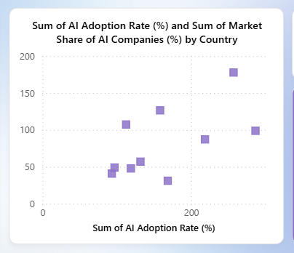

#### **2. Industry-wise Job Loss Impact (Power BI)**

* Shows job displacement percentage by industry and region.
* Includes slicers to filter by country or year.
* 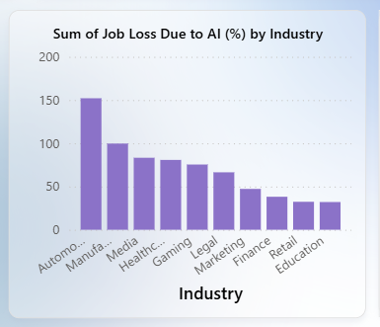Stacked bar chart combined with line chart to compare human-AI collaboration.

#### **3. Human-AI Collaboration Rate – Power BI Dashboard**

* Showcases how collaboration between humans and AI is evolving across industries and countries.
* Visualized using **multi-axis bar and line graphs** in Power BI.
* 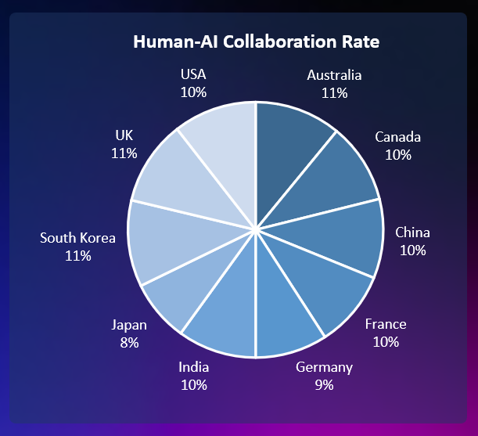Includes filters for region and sector, and highlights correlation with productivity metrics.

#### **4. AI Regulation Status by Country – Tableau + Excel**

* A dual visualization using **Tableau pie and bar charts**, supported by **Excel classification tables**.
* Countries are classified into: **Full Regulation**, **Partial Regulation**, or **No Regulation**.
* 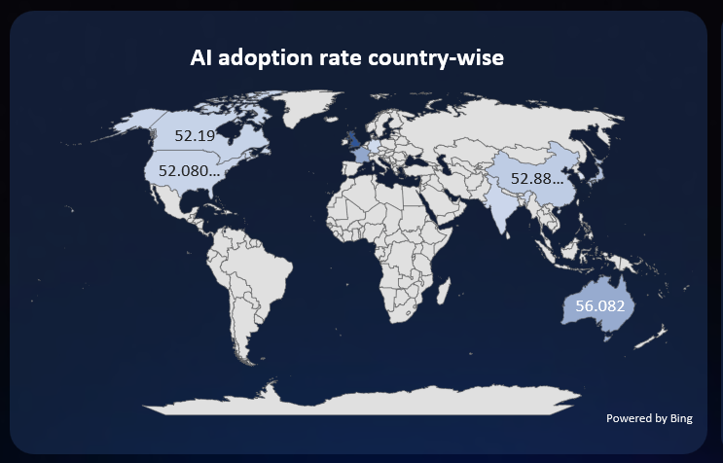Interactive slicers let users explore policy maturity by region or development status.

**5. Market Share vs. AI Adoption Rate – Power BI Dashboard**

* Compares AI company market share with national AI adoption levels.
* Features **scatter plots and dual bar charts** to indicate alignment or gaps between market presence and technology penetration.
* 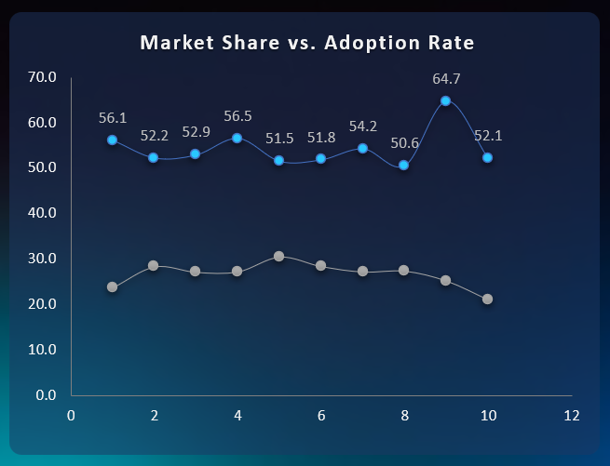Useful for identifying whether market-leading tools are actually influencing national AI progress.

# **YEAR-WISE CASE STUDY: GLOBAL AI IMPACT (2020–2025)**

To understand how Artificial Intelligence evolved globally, we conducted a **year-wise study** of key events, shifts, and trends in AI adoption, regulation, and socio-economic impact. Each year showcases how different regions adapted AI based on their priorities, capabilities, and challenges. Our findings are supported by **Excel-based data analysis**, **Python-generated trend models**, and **Power BI dashboards**.

#### **2020 – The Foundation Year**

* The global pandemic accelerated AI integration in healthcare and remote services.
* The **United States** invested in telemedicine AI; **China** expanded surveillance and logistics AI.
* **India** initiated national AI frameworks; **Africa** piloted mobile AI in fintech.
* Global regulation was minimal; AI was viewed more as a necessity than a risk.

#### **2021 – Mainstream Adoption Begins**

* AI adoption became mainstream in large enterprises and governments.
* **China** led in AI-generated content and facial recognition.
* **The US and EU** began early discussions on AI ethics and governance.
* **India’s** startup ecosystem embraced AI for education and fintech.
* Power BI visualizations showed a clear rise in human-AI collaboration across all regions.

#### **2022 – Economic & Ethical Turning Point**

* Major growth in **revenue due to AI** in the **US and EU**; **China** saw significant job displacement.
* **The EU** finalized key AI regulations, becoming a global leader in ethical AI policy.
* **India** expanded AI to public healthcare; **Africa** began scaling education tech with AI tools.
* Excel models tracked adoption vs. regulation readiness; Python forecasted adoption growth curves.

#### **2023 – Growth, Innovation & Market Share Race**

* **China** surpassed others in market share of AI companies; **Power BI dashboards** showed the disparity between market leadership and country adoption.
* **India** recorded over 50% growth in human-AI collaboration.
* **The US** deployed AI in justice systems; **Africa** used AI in mobile health and climate monitoring.
* Regional dashboards displayed significant AI penetration into public services and innovation sectors.

#### **2024 – Predictive AI and Policy Alignment**

* Focus on **explainable AI** grew in the **US** and **EU**, aiming to build public trust.
* **China and India** accelerated AI adoption in agriculture and smart logistics.
* **Africa** witnessed localized innovations; adoption reached 30% in certain tech hubs.
* **Python time-series forecasting** predicted AI adoption trends up to 2030 with high accuracy.

#### **2025 – Global Convergence**

* AI became embedded in daily life: transportation, education, governance, and healthcare.
* Regulatory frameworks matured globally: most countries had at least partial AI governance.
* **The US and EU** emphasized sustainable AI; **China** and **India** focused on scaling reach.
* Power BI global dashboards showcased a convergence in AI maturity among top and emerging economies.

# **CONCLUSION**

The “Global AI Impact” project has revealed that Artificial Intelligence is no longer an emerging trend, but a **core driver of transformation across countries, industries, and societies**. Through a combination of **Excel-based data analysis**, **Python machine learning models**, and **interactive dashboards in Power BI**, we were able to uncover the multifaceted impact of AI from 2020 to 2025.

Our findings highlight how AI adoption is not uniform. Countries like the **United States** and **China** lead in innovation and market penetration, while the **European Union** champions ethical and regulatory leadership. **India** is rapidly catching up with scalable, sector-based AI solutions, while **Africa** is emerging with localized, mobile-first AI applications in fintech and healthcare.

From the data analyzed, several key patterns emerged:

* **AI Adoption Rates** have consistently increased year-over-year, with developing nations showing the fastest growth post-2022.
* **Job Loss Due to AI** has affected traditional industries, but **Python-based forecasting** indicates this is counterbalanced by the rise in **human-AI collaboration** roles.
* **Consumer Trust** plays a critical role in AI success, especially in the EU and India where ethical deployment strategies have been prioritized.
* **Market Share vs Adoption** visualizations built in Power BI exposed gaps between leading AI tool providers and the actual user-level penetration in various countries.
* **Regulation Status Dashboards** show a clear global shift toward structured AI governance by 2025, with most countries moving from unregulated to partially or fully regulated environments.

By aligning technical tools with social and economic indicators, we built a **comprehensive and accessible view of AI’s global impact**. The integration of data visualization allowed for deeper, actionable insights, while Python enabled forward-looking predictive modeling.

In conclusion, the future of AI is not just about innovation—it is about **responsible, inclusive, and data-driven transformation**. As nations and organizations move forward, they must embrace AI not only for what it can do, but for how it can be **ethically and equitably implemented**. This project serves as both a reflection of the present and a roadmap for the AI-driven future.

# **FUTURE SCOPE**

As Artificial Intelligence continues to evolve at a rapid pace, the scope of this project can be significantly expanded to stay relevant and insightful for future decision-making. The “Global AI Impact” project, powered by **Excel**, **Power BI**, and **Python**, sets a strong foundation for further analysis—but it also opens up several new opportunities for deeper exploration, real-time tracking, and predictive analytics.

#### **1. Real-Time AI Monitoring Dashboards**

* Future iterations can include **live dashboards** connected to real-time AI datasets from international sources such as the OECD AI Observatory, Stanford AI Index, or global tech journals.
* **Power BI APIs and web connectors** can be used to stream data updates, providing policy-makers and researchers with up-to-date insights on AI adoption, regulation changes, or economic shifts.

#### **2. Expansion of Industry-Specific AI Dashboards**

* While this project focused on global trends and national-level data, there is immense scope to **develop deep-dives into sectors** such as healthcare, education, agriculture, manufacturing, and defense.
* Using **Excel for data structuring** and **Power BI for granular dashboards**, sector-specific KPIs can offer highly actionable insights.

#### **3. AI Ethics and Bias Detection Models**

* Future work can incorporate **Python-based machine learning models** that not only predict AI impact, but also identify **biases and risks** associated with AI usage in different countries or sectors.
* Sentiment analysis, fairness models, and explainability metrics can be included to analyze the **ethical footprint of AI**.

#### **4. AI Readiness and Capability Index**

* We can build a custom “AI Readiness Index” using weighted scoring systems in **Excel and Python**, ranking countries based on:
  + AI investment levels
  + Digital infrastructure
  + Education and talent availability
  + Regulatory maturity
* These scores can be visualized as interactive maps and ranking charts in Power BI.

#### **5. Predictive Scenarios Until 2030**

* **Advanced time-series forecasting models** (e.g., LSTM, ARIMA) in **Python** can be used to project future trends in AI adoption, job transformation, and economic output up to the year 2030.
* These predictive KPIs can be embedded into **Power BI dashboards** with slicers for “Optimistic”, “Neutral”, and “Cautious” development scenarios.

#### **6. Global AI Sustainability Tracker**

* As AI begins influencing climate research and resource optimization, a **sustainability dashboard** can track the role of AI in achieving SDGs (Sustainable Development Goals).
* Data can be organized in **Excel** and visualized using **Power BI environmental impact charts**.

# **REFERENCES**

# 

1. Siegmann, Charlotte, and Markus Anderljung. "The Brussels effect and artificial intelligence: How EU regulation will impact the global AI market." arXiv preprint arXiv:2208.12645 (2022).
2. Alabdulatif, Abdulatif. "The global impact of artificial intelligence." Technical and Technological Solutions Towards a Sustainable Society and Circular Economy. Cham: Springer Nature Switzerland, 2024. 263-277.
3. Chen, Nicholas, et al. "Global economic impacts associated with artificial intelligence." Analysis Group 1 (2016).
4. Pachegowda, Chandregowda. "The Global Impact of AI-Artificial Intelligence: Recent Advances and Future Directions, A Review." arXiv preprint arXiv:2401.12223 (2023).
5. Hagerty, Alexa, and Igor Rubinov. "Global AI ethics: a review of the social impacts and ethical
6. implications of artificial intelligence." arXiv preprint arXiv:1907.07892 (2019).